Milesi, Angelo John
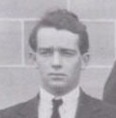
Graduate of School of Forestry, Adelaide University. Enrolled in the first ever class in 1926. The students moved to Canberra in 1927. Was Officer in Charge of Narrogin District for 17 years. Responsible for establishment of most of the mallet plantation. Then Superintendent Fire Control in Perth. In 1946 was a part time lecturer in fire control at the Australian Forestry School. Foundation member of the Bush Fires Board in 1955. Milesi Plantation in the Sunklands named after him. Retired 30.9.1968.

